Software Requirements

Painkiller Injection System

Group 10

Author: WeichenLu

Table of Contents

System Objective 3

Domain Analysis 3

System Architecture 5

Use Cases 6

Software Requirements 7

◆ R1: Patient Interaction 7

◆ R2: Physician UI 7

◆ R3: Injection processor 7

## System Objective

In this project, we are developing a system to simplify the process of painkiller injection after surgery in the hospital. The system will manage the injection rate, allow physicians to change the injection details, and provide a button for patients to apply a shot of extra injection to reduce their pain.

## Domain Analysis

The participants of activities around the painkiller injection system can be divided into Patients, Physicians and the system itself.

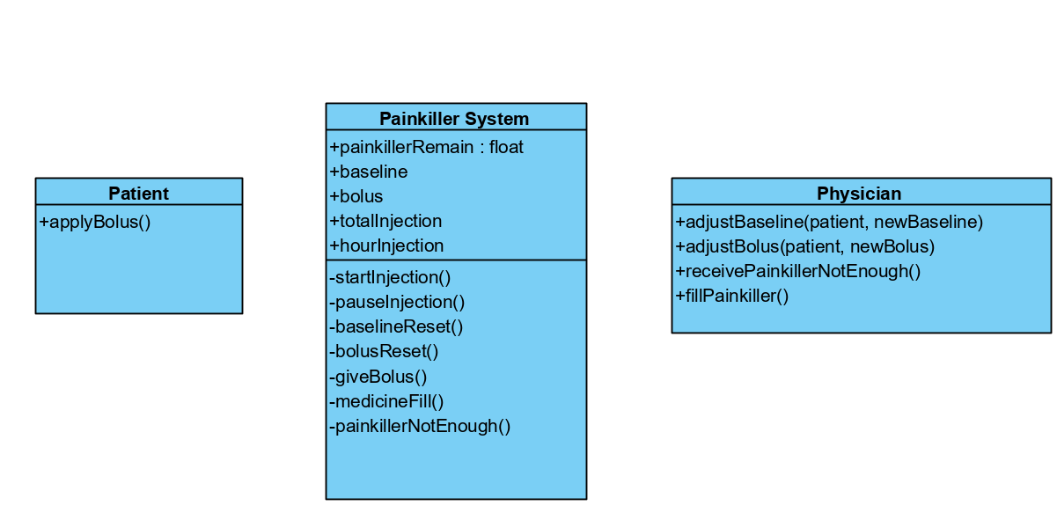

Their relationships are shown in the following figure:

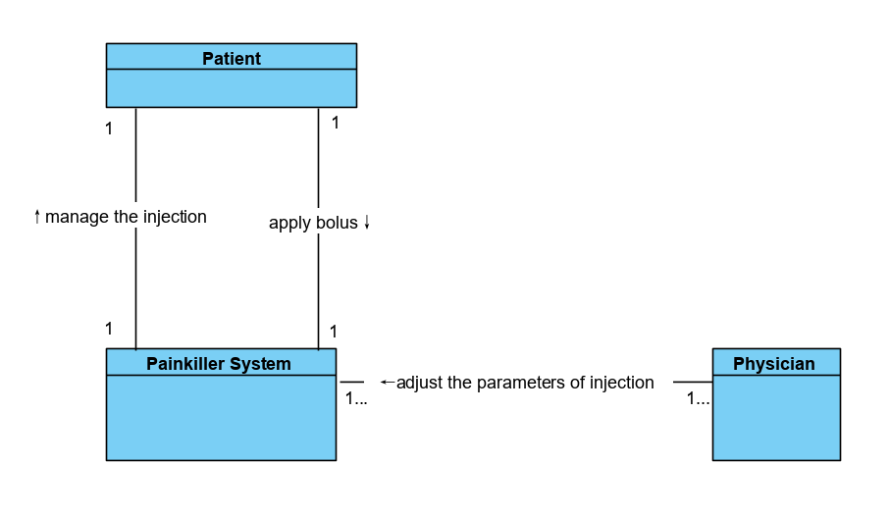

Here is the sequence of events for a patient to apply a bolus:

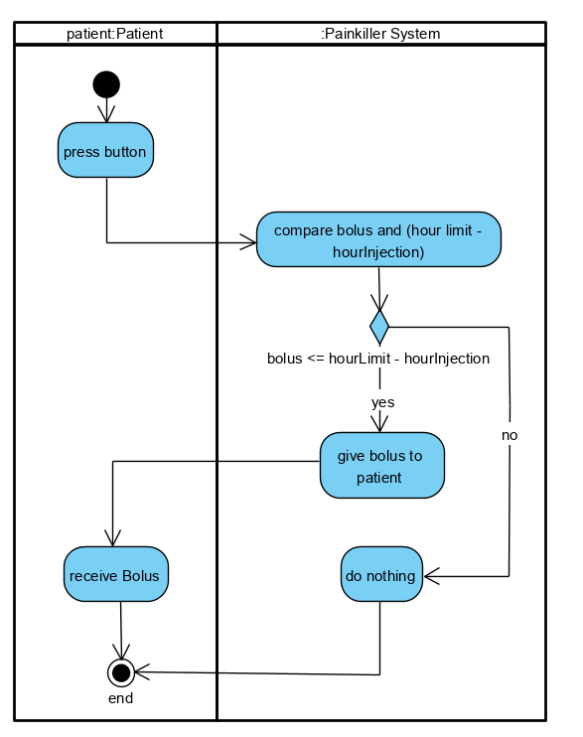

Here is the sequence of events for a physician to adjust the injection parameters:

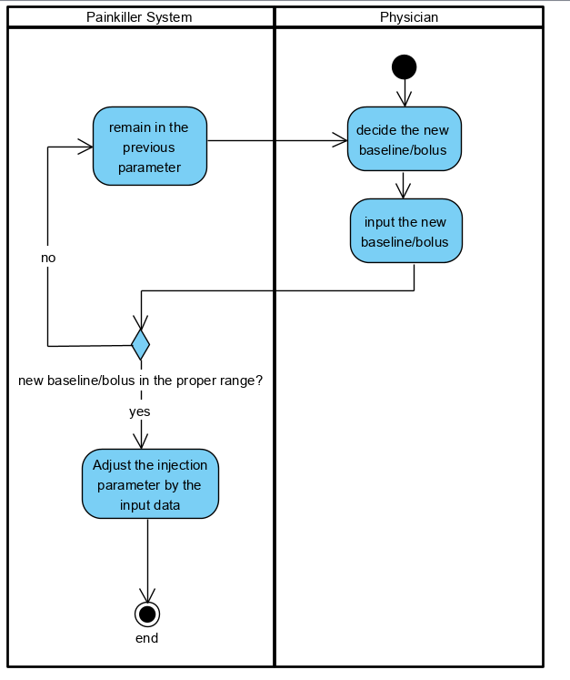

## System Architecture

We will build a system that allow patients to apply bolus, and the physicians can change the parameter of injection process.

The system architecture is shown below:

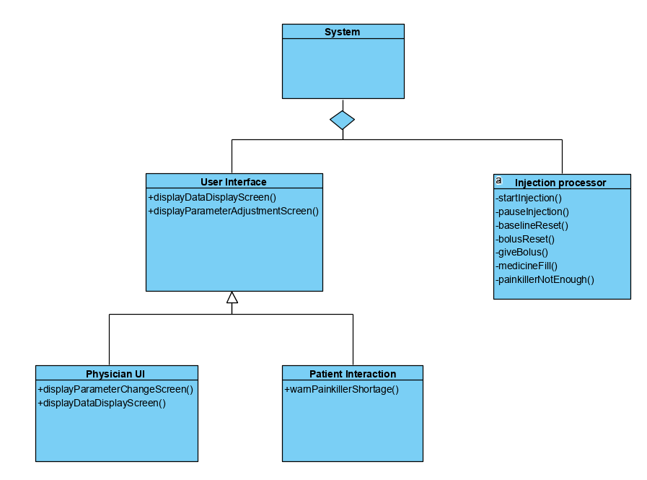

## Use Cases

The system should fulfill the use cases from patient’s and physician’s perspectives:

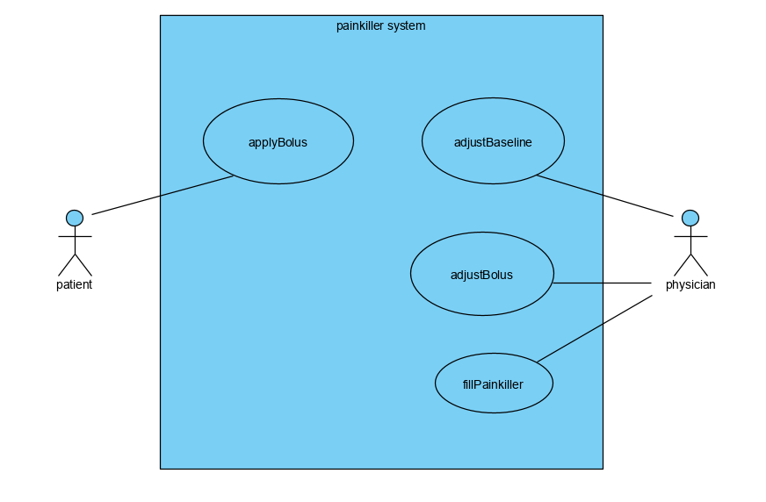

## Software Requirements

* **R1: Patient Interaction**
* R1.1 The patient should be able to press a button for a bolus.
* The button should be in a place where is convenient for the patient to press.
* **R2: Physician UI**
* R2.1 The physician should be able to see the detailed information about the injection of certain patient.
* R2.2 The physician should be able to adjust the baseline and bolus setting of certain patient.
* R2.3 The physician should be able to fill in the painkiller container.
* **R3: Injection processor**
* R3.1 The processor should calculate the amount of injection of certain patient.
* R3.2 The processor should be able to pause injection if the amount of injection reaches either of the hour limit or daily limit.
* R3.3 The processor should be able to continue injection if the amount of injection is under the hour limit and daily limit.
* R3.4 (Extra)The processor can be able to alert the physician if the remaining painkiller is not enough for one bolus.